**1. Stimulants**

Stimulants are substances that increase the activity of the central nervous system, resulting in increased blood pressure and heart rate, more alertness, and sped-up behavior and thinking. Among the most troublesome stimulants are *cocaine* and *amphetamines,* whose effects on people are very similar. When users report different effects, it is often because they have ingested different amounts of the drugs. Two other widely used and legal stimulants are *caffeine* and *nicotine*

1. **Cocaine**:

Cocaine—the central active ingredient of the coca plant, found in South America— is the most powerful natural stimulant now known (Acosta, Haller, & Schnoll, 2011, 2005). The drug was first separated from the plant in 1865. Native people of South America, however, have chewed the leaves of the plant since prehistoric times for the energy and alertness the drug offers.

Processed cocaine (hydrochloride powder) is an odorless, white, fluffy powder. For recreational use, it is most often snorted so that it is absorbed through the mucous membrane of the nose. Some users prefer the more powerful effects of injecting cocaine intravenously or smoking it in a pipe or cigarette.

For years’ people believed that cocaine posed few problems aside from intoxication and, on occasion, temporary psychosis.

Cocaine brings on a euphoric rush of well-being and confidence. At first cocaine stimulates the higher centers of the central nervous system, making users feel excited, energetic, talkative, and even euphoric. As more is taken, it stimulates other centers of the central nervous system, producing a faster pulse, higher blood pressure, faster and deeper breathing, and further arousal and wakefulness.

Cocaine apparently produces these effects largely by increasing supplies of the neurotransmitter *dopamine* at key neurons throughout the brain (Haile, 2012 Kosten et al., 2008). Excessive amounts of dopamine travel to receiving neurons throughout the central nervous system and overstimulate them. Cocaine appears to also increase the activity of the neurotransmitters *norepinephrine* and *serotonin* in some areas of the brain (Hart & Ksir, 2014; Haile, 2012).

High doses of the drug produce ***cocaine intoxication,***whose symptoms are poor muscle coordination, grandiosity, bad judgment, anger, aggression, compulsive be havior, anxiety, and confusion. Some people have hallucinations, delusions, or both, a condition called *cocaine-induced psychosis.*

As the stimulant effects of cocaine subside, the user goes through a depression- like letdown, popularly called *crashing,* a pattern that may also include headaches, dizziness, and fainting (Acosta et al., 2011, 2005). For occasional users, the after- effects usually disappear within 24 hours, but they may last longer for people who have taken a particularly high dose. These people may sink into a stupor, deep sleep, or, in some cases, coma.

**What Are the Dangers of Cocaine?** Aside from cocaine’s harmful ef- fects on behavior, cognition, and emotion, the drug poses serious physical dangers (Paczynski & Gold, 2011) Cocaine use has also been linked to many suicides (Petit et al., 2012).

The greatest danger of cocaine use is an **overdose**. Excessive doses have a strong effect on the respiratory center of the brain, at first stimulating it and **then depressing it to the point where breathing may stop.**

Cocaine can also create major, even fatal, heart irregularities or brain seizures that bring breathing or heart functioning to a sudden stop (Acosta et al., 2011, 2005). In addition, pregnant women who use cocaine run the risk of having a miscarriage and of having children with predispositions to later drug use and with abnormalities in immune functioning, attention and learning, thyroid size, and dopamine and sero- tonin activity in the brain (Minnes et al., 2014; Hart & Ksir, 2014; Kosten et al., 2008).

1. **Amphetamines**

**Amphetamines** are stimulant drugs that are manufactured in the laboratory. First produced in the 1930s to help treat asthma, amphetamines soon became popular among people trying to lose weight; athletes seeking an extra burst of energy; soldiers, truck drivers, and pilots trying to stay awake; and students studying for exams through the night (Haile, 2012). Physicians now know the drugs are far too dangerous to be used so casually, and they prescribe them much less freely.

Amphetamines are most often taken in pill or capsule form, although some people inject the drugs intravenously or smoke them for a quicker, more powerful effect. Like cocaine, amphetamines increase energy and alertness and reduce appetite when taken in small doses; produce a rush, intoxication, and psychosis in high doses; and cause an emotional letdown as they leave the body.

Also like cocaine, amphetamines stimulate the central nervous system by increasing the release of the neurotransmitters dopamine, norepinephrine, and serotonin throughout the brain (Hart & Ksir, 2014; Haile, 2012).

One kind of amphetamine, **methamphetamine** (**nicknamed *crank*), has surged in popularity in recent years and so warrants special focus. It is available in the form of crystals (also known by the street names *ice* and *crystal meth*), which users smoke.**

Methamphetamine increases activity of the neurotransmitters dopamine, serotonin, and norepinephrine, producing increased arousal, attention, and related effects (Acosta et al., 2011, 2005; Dean & London, 2010). It can have serious negative effects on a user’s physical, mental, and social life. Of particular concern is that it damages nerve endings, a problem called ***neurotoxicity.***

But users focus more on methamphetamine’s immediate positive impact, including perceptions by many that it makes them feel hypersexual and uninhibited (Washton & Zweben, 2008; Jefferson, 2005).

1. Caffeine

**Caffeine** is the world’s most widely used stimulant. **Around 80 percent of the world’s population consumes it daily. Most of this caffeine is taken in the form of coffee (from the coffee bean); the rest is consumed in tea (from the tea leaf), cola (from the kola nut), so-called *energy drinks,* chocolate (from the cocoa bean), and numerous prescription and over-the-counter medications, such as Excedrin.**

Around 99 percent of ingested caffeine is absorbed by the body and reaches its peak concentration within an hour. It acts as a stimulant of the central nervous system, again producing a release of the neurotransmitters dopamine, serotonin, and norepinephrine in the brain. Thus it raises a person’s arousal and motor activity and reduces fatigue. It can also disrupt mood, fine motor movement, and reaction time and may interfere with sleep

At high doses, it increases gastric acid secretions in the stomach and the rate of breathing. More than two to three cups of brewed coffee (250 milligrams of caffeine) can produce caffeine intoxication, which may include such symptoms as **restless- ness, nervousness, anxiety, stomach disturbances, twitching, and a faster heart rate** (Juliano et al., 2011; Paton & Beer, 2001).

Doses larger than 10 grams of caffeine (about 100 cups of coffee) can cause grand mal seizures and fatal respiratory failure. Many people who suddenly stop or cut back on their usual intake of caffeine— even those whose regular consumption is low (two and a half cups of coffee daily or seven cans of cola)—have withdrawal symptoms.

One pioneering study had adult participants consume their usual caffeine-filled drinks and foods for 2 days, then abstain from all caffeine-containing foods for 2 days while taking placebo pills that they thought contained caffeine, and then abstain from such foods for 2 days while taking actual caffeine pills (Silverman et al., 1992). More participants had headaches (52 percent), depression (11 percent), anxiety (8 percent), and fatigue (8 percent) during the 2-day placebo period than during the caffeine periods.

Although DSM-5 acknowledges that many people go through caffeine intoxication and caffeine withdrawal, it does not go so far as to list *caffeine use disorder* as an official category (APA, 2013). Instead, it views this disorder as a condition that has received some support in clinical studies and that may warrant official classification in a future edition of the DSM, depending on the outcome of future studies. If added to the DSM, they key criteria for this disorder would be a 1-year pat- tern of problematic caffeine use, unsuccessful efforts to reduce caffeine use, awareness that one’s continued caffeine use is causing a repeated physical or psychological problem, withdrawal symptoms if one stops caffeine use, and significant impairment or distress.

On the other hand, studies do suggest that there may be correlations between high doses of caffeine and heart rhythm irregularities (arrhythmias), high cholesterol levels, and risk of heart attacks (Hart & Ksir, 2014). And some, but not all, studies raise the possibility that very high doses of caffeine during pregnancy may increase the risk of miscarriage.

**B E T W EE N T H E L I N E S**

Energy drinks and young teens

**Around 30 percent of middle school students report consuming energy drinks. Around 60 percent consume soft drinks daily.**

(Information from terry-Mcelrath et al., 2014)

Red Bull, like other popular energy drinks, contains huge—potentially dangerous—amounts of caffeine and other legal stimulants.

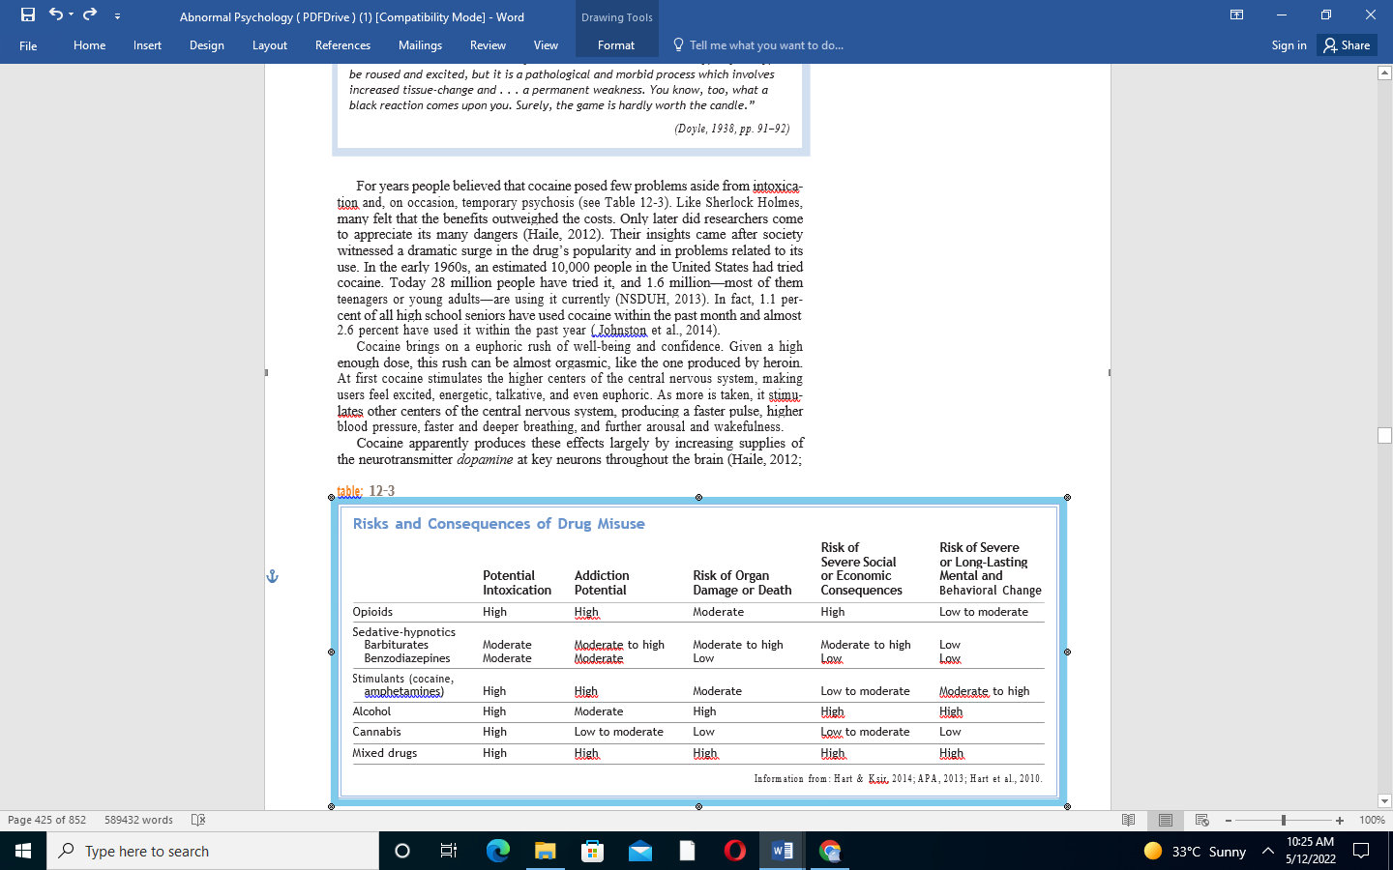

1. **Nicotine**:

**Nicotine is a highly addictive chemical compound present in a tobacco plant**. [All tobacco products contain nicotine](https://www.fda.gov/tobacco-products/products-guidance-regulations/products-ingredients-components), including cigarettes, non-combusted cigarettes (commonly referred to as “heat-not-burn tobacco products” or “heated tobacco products”), cigars, smokeless tobacco (such as dip, snuff, snus, and chewing tobacco), hookah tobacco, and most e-cigarettes.

Using any tobacco product can lead to nicotine addiction. This is because nicotine can change the way the brain works, causing cravings for more of it.

Some tobacco products, like cigarettes, are designed to deliver nicotine to the brain within seconds,making it easier to become dependent on nicotine and more difficult to quit. While nicotine naturally occurs in the tobacco plant itself, some tobacco products contain additives that may make it easier for your body to absorb more nicotine

**What Makes Tobacco Use Harmful?**

Nicotine is what keeps people using tobacco products. **However, it’s the thousands of chemicals contained in tobacco and tobacco smoke that make tobacco use so deadly.** Some of these chemicals, known to cause lung damage, are also found in some e-cigarette aerosols.

This toxic mix of chemicals—not nicotine—cause the [serious health effects among those who use tobacco products](https://www.fda.gov/tobacco-products/public-health-education/health-effects-tobacco-use), including fatal lung diseases, like chronic obstructive pulmonary disease (COPD) and cancer.

Tobacco products containing nicotine pose different levels of health risk to adult users. Combustible products, or products that burn tobacco, are the most harmful. An example of a combustible product is cigarettes, which deliver more than 7,000 chemicals along with nicotine that makes it hard to quit.

FDA-approved nicotine replacement therapies (NRTs), such as gums and lozenges, are the least harmful. Noncombustible products, such as heat-not-burn tobacco products, smokeless tobacco, and e-cigarettes, fall somewhere in between combustible products and NRTs.

If you’re an adult who currently doesn’t use tobacco products, we strongly encourage you to stay tobacco-free. If you’re an adult who currently uses tobacco products, there are [resources to help you quit](https://www.fda.gov/tobacco-products/health-effects-tobacco-use/quitting-smoking-and-other-tobacco-public-health-resources).

